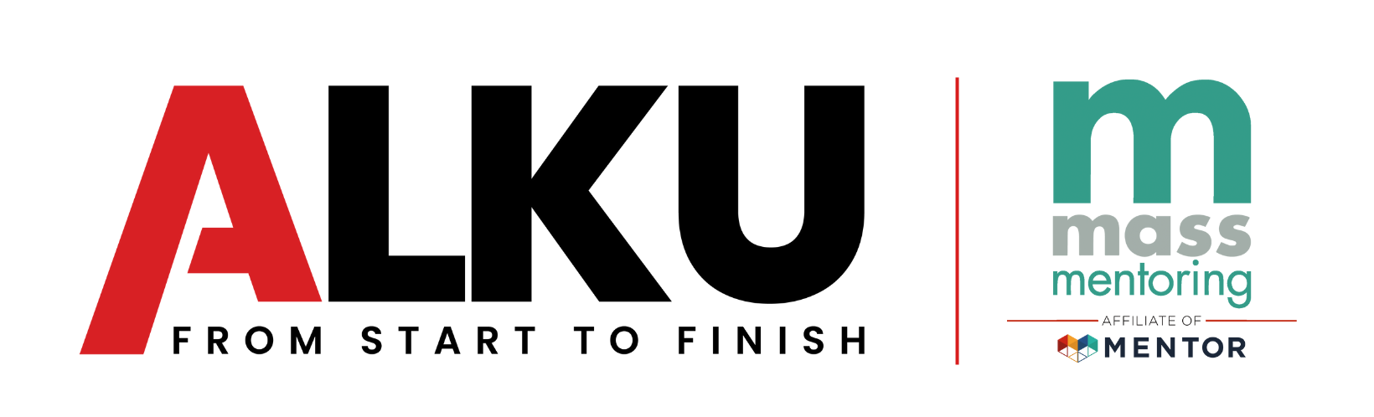
2025 ALKU Scholarship Application
Deadline: September 25, 2025

About the Scholarship

Each year, since 2015, ALKU has partnered with Mass Mentoring Partnership to provide a $30,000 academic scholarship or $7,500 per academic year, to a rising High School senior in Massachusetts. This recipient of the scholarship has been positively impacted and engaged in a mentoring relationship for at least one year and has plans to attend a 4-year College or University.

At ALKU, we believe in the power of mentoring. Our mission as a company is to provide our employees the tools and resources to grow their careers. By actively engaging in the mentoring cause, we can utilize the resources we have, and the values we pride ourselves on cultivating, to empower those who need support. ALKU chose the mentoring cause because of the value and impact that just one positive youth-adult mentoring relationship can have on a young person.

This scholarship provides an opportunity for young people to apply for financial support in pursuit of their goal to attend college and earn a bachelor’s degree.

This year, the ALKU Scholarship will be awarded to one recipient. Each scholarship will total $30,000 over the course of 4 years.

All application materials must be submitted online by 11:59 PM on Thursday, September 25, 2025. Late and/or incomplete applications will not be considered.

If you have any questions about this application, please contact Olivia Taylor, Advancement Operations Manager, at otaylor@massmentors.org.

Guidelines & Criteria

Students must complete their own applications, but mentors may assist.

- Applicants must be enrolled in a high school in Massachusetts and must be a rising senior (Class of 2026 / student will be a high school senior in Fall 2025).
  - Only seniors with an expected high school graduation date of 2026 are eligible to apply for the scholarship.
- Applicants must intend to apply to a four-year, accredited institution to acquire a bachelor’s degree in any field, beginning in Fall 2026.

- Eligible applicants must be engaged in a quality mentoring relationship that has been in existence for at least one year.
  - This mentoring relationship can be with any adult, except for the applicant's parent or legal guardian, who provides caring, consistent guidance and support.

- Applications must include one (1) letter of recommendation from the applicant’s mentor.
  - This letter should describe how the student has benefited from their mentoring relationship, what the young person’s educational goals and challenges are, and why they are deserving of this scholarship.

- Applicants must upload one (1) photograph of themselves together with their mentor*.
*Note, the photograph will not be shown to the review committee, but may be used in event materials if selected as the 2025 ALKU Scholar. You may opt out during the application process.

- Applicants must attain an average GPA of 2.75 or higher.
  - If selected as a finalist, the applicant must provide a copy of their high school transcript verifying their GPA.

Applications will be evaluated according to the following criteria:

- Demonstrated need for scholarship
- Clear desire, motivation, and passion to attend college/university (please indicate a post-secondary education plan, if applicable)
- Establishment of impactful mentoring relationship
- Demonstrated and detailed work and/or leadership experience outside of school (employment, internships, volunteer work, community involvement)

If awarded, Mass Mentoring Partnership (MMP) requires the following:
- Signed ALKU Scholarship Award Letter of acceptance
- Signed Media Consent Form (must be signed by parent/guardian if scholar is under the age of 18)
- Attendance by scholar and mentor at Mass Mentoring Partnership’s signature event, Cheers to Mentoring, on the evening of November 18, 2025. At this event, Mark Eldridge, ALKU CEO and founder of the ALKU Scholarship, alongside other ALKU employees, will be there to present the winning scholar with the award.
- Winning scholar will be expected to attend an annual meeting with previous ALKU scholarship winners.
- Winning scholar must provide yearly updates on college GPA. Scholars must maintain a minimum GPA of 2.75 to maintain their scholarship award.

Scholarship Use: The award must be used for the student’s educational pursuits, such as college tuition, books, or other materials and expenses necessary for college.

Disbursement: The award will be disbursed in $3,750 increments, once per semester, over the scholar's consecutive four years in college, totaling $30,000. The scholarship funds must be used within four years, beginning in Fall 2026, and ending in Spring 2030. If necessary, a one-year extension may be granted. This request would be considered on a case-by-case basis.

Applicant Information

Applicant Name (First Name, Last Name)
Age
Pronouns (optional)
Mailing Address
Phone
Email
Affiliated Mentoring Program (If applicable)

High School
Current High School GPA
Confirm Grade Level (applicant will be in 12th grade starting in Fall 2025)
Mentor Information:
- How did you meet your mentor?
- Who is your mentor? Tell us about your relationship with your mentor and why it is important to you.
- How has your mentor impacted your opportunity or ambition to attend college?
- How long have you known your mentor?

Educational Plans:
1. Please describe your future academic plans and goals beyond high school.
2. When you think about your future, where do you picture yourself academically or beyond?
3. What major/area of study are you planning to pursue and why? Are there any universities, colleges, or institutions you are hoping to attend and/or plan to apply to?

Challenges Faced:
- Have you faced any challenges, obstacles, or adversity that have impacted your personal or educational journey? How have you overcome these challenges? Please explain.
- How do you plan on paying for your college education?
2a. Do you plan on applying for other scholarships?
2b. Do you plan on applying for federal financial aid?

Accomplishments:
- Describe the accomplishment(s) of which you are proudest.

Work, Leadership and/or Volunteer Experience:
- Please describe your work, volunteer, and leadership experience (paid employment, internships, and/or volunteer work), including any specific programs or projects to which you are connected.

Other/Personal Statement:
Topic: Tell us something about your background, identity, interest, or a talent that is so meaningful to you that your application would be incomplete without it.

Personal Statement: In the space below, write a personal statement (100-200 words). The personal statement should highlight your story, your strengths, anything that is unique or impressive about you, and allow the selection committee to see what details of your life help set you apart from other candidates.

Additionally, you should use the opportunity to discuss any significant obstacles or hardships that you have had to overcome and what personal characteristics you possess that would improve your prospects for success.

Upload letter of recommendation from mentor:
Please title the document with your First and Last Name and "Letter." If you have more than one letter of recommendation, add a 2 at the end.
Ex. "John Smith Letter" and/or "John Smith Letter 2"

Upload photo of you and your mentor:
Please title the image with your First and Last Name and "Picture"
Ex. "John Smith Picture"

What happens after I submit my application?

After applications are closed, applications are distributed to the ALKU Scholarship Committee along with scoring rubrics and score sheets. Committee members undergo training by the MMP Program Services Team prior to scoring applications. The Committee will then review and score all of the applications using a standardized rubric. Once all of the applications have gone through the first round of review and scoring, MMP compiles the scores to get the top 15 applications. Those applications are presented to the committee as a group, with the main reviewers of the application providing additional insight and lead discussions. The Committee will then vote and decide on the top 5 applicants. MMP’s CEO and ALKU’s CEO will review the top 5 applications and ultimately choose the 2025 ALKU Scholar on October 28th!

